**SYSTEM REQUIREMENTS SPECIFICATION DOCUMENT**

Document Number: BBT 3104-SyRS-2020/04

Version: 1.0

Review Date:

Submission Date:

Case Study: Wanji’s Food Industries

Group Number: 36

Team Members:

|  |  |  |
| --- | --- | --- |
|  | **Student Details** | **Mark Awarded** |
|  | Lilian Thairu – 111878. – Group A – SU Email: Lilian.Thairu@strathmore.edu |  |
|  | Lydia Kahuria – 110875. – Group A– SU Email:Lydia.Kahuria@strathmore.edu |  |
|  | Fredah Kioko– 103428. – Group – SU Email:Fredah.Kioko@strathmore.edu |  |

|  |  |  |
| --- | --- | --- |
| **Version Change** | **Date of Change** | **Changes Made** |
| ***<Example>***  Version 1.0 to 1.2 | 12th April 2020 | Added list of constraints |
| ***<Example>***  Version 1.2 to 1.6 | 16th April 2020 | Added ERD diagram |
|  |  |  |
|  |  |  |
|  |  |  |
|  |  |  |
|  |  |  |
|  |  |  |

# Executive Summary

***<This will be filled in at the end. It is like an abstract>***

**Table of Contents**

Executive Summary 1

List of Figures 3

List of Tables 4

List of Models 5

Chapter 1. Introduction 6

1.1 The Mission of the Business 6

1.2 The Day to Day Operations of the Business 6

1.3 Statement of Objectives: Aim of Designing and Implementing the Database 6

Chapter 2. System Capabilities 7

A. Example1 Data (E.g. Patient Data or Client Data or Bicycle Data) 7

B. Example2 Data 7

C. Example3 Data 7

Chapter 3. System Conditions 8

A. Example1 Data (E.g. Patient Data or Client Data or Bicycle Data) 8

B. Example2 Data 8

C. Example3 Data 8

Chapter 4. System Constraints 9

A. Example1 Data (E.g. Patient Data or Client Data or Bicycle Data) 9

B. Example2 Data 9

C. Example3 Data 9

Chapter 5. Assumptions 10

Chapter 6. Database Design 11

a. Entity Relationship Diagram Based on the Chen Notation 11

b. Database Schema Based on the UML Notation 12

Chapter 7. Normalization 13

a. List of Functional Dependencies 13

b. Normal Forms 13

Chapter 8. DDL Statements 14

# List of Figures

# List of Tables

# Introduction

## The Mission of the Business

The mission of Wanji’s Food Industries is to process healthy and nutritious food products target to a specific group of people with specific needs hence solving the societal problem of malnutrition by making them affordable to the consumers.

## The Day to Day Operations of the Business

***<Create a flowchart here that represents the business processes involved in producing the business' main product/service>***

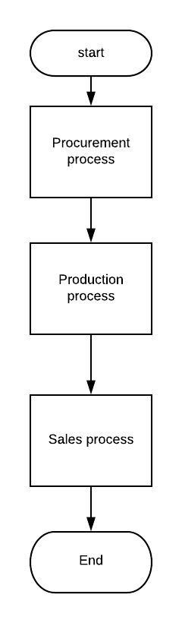

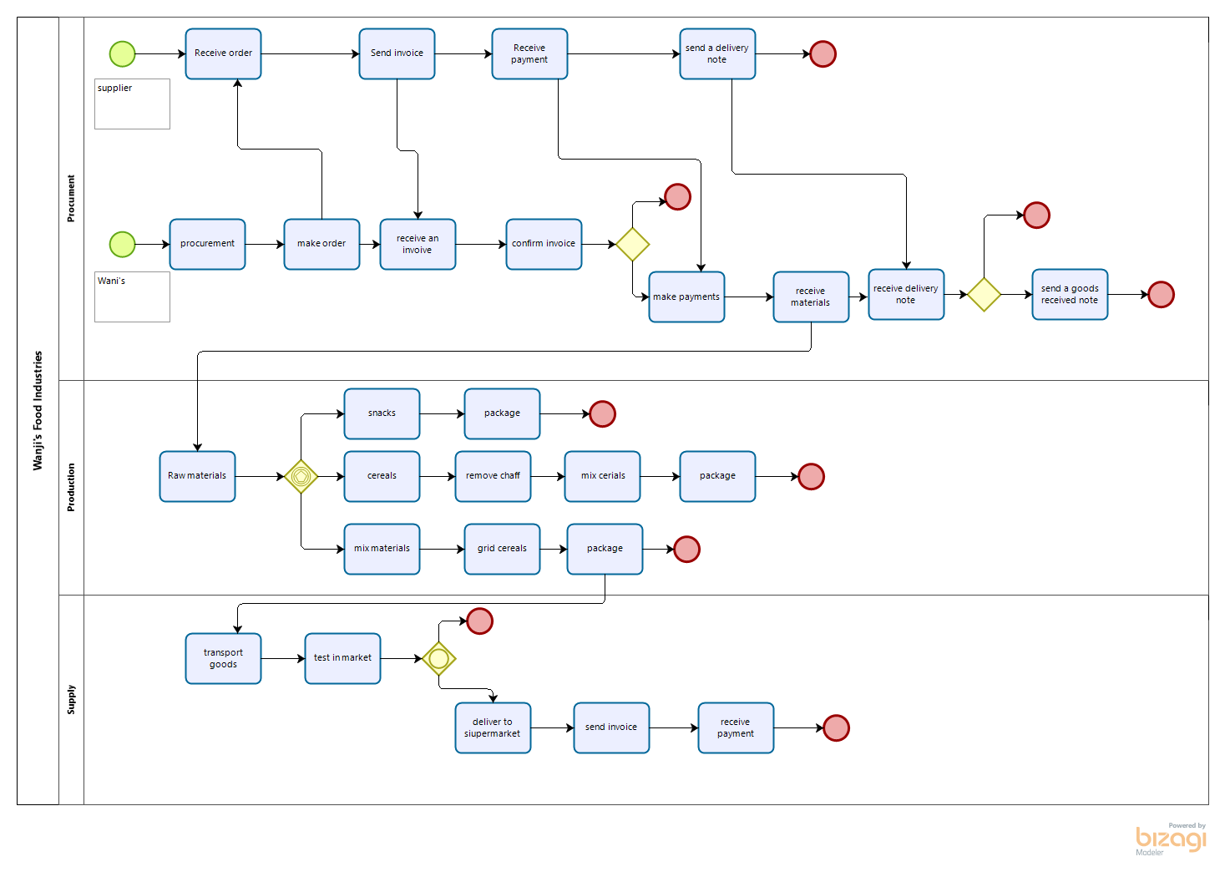

***<Create a Data Flow Diagram (DFD) that represents the flow of information through the business organization in the case study>***

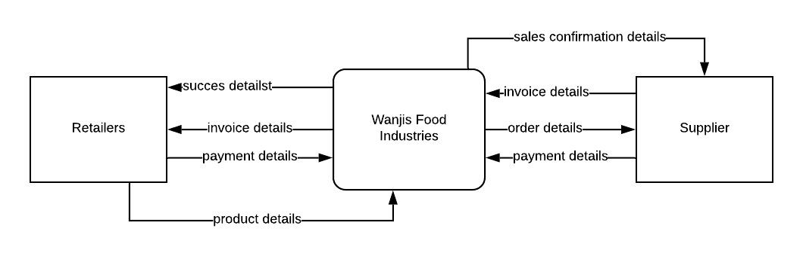

Figure . context diagram

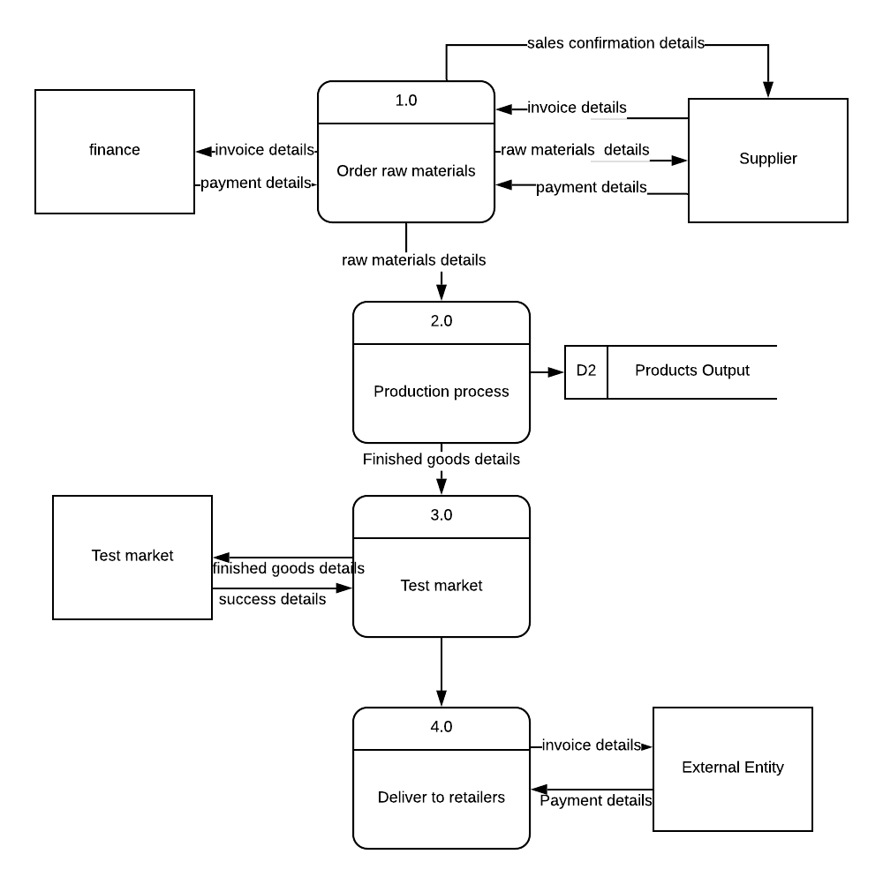

Figure . DFD 1

## Statement of Objectives

***<Hint: Think in terms of an IT-based solution to address the negative effects associated with the non-value adding activities in the organization’s business processes>***

1. To record the inventory of the organization in a database in order to generate reports that may be used to make decisions in the future.
2. To store customer orders in order to know the demand of the products and the success rate of each product in a database management system
3. To analyze the stored Purchase details of raw materials against the output of products processes by the industry using business intelligence dashboard
4. To manage staff details and know the activeness of each member and any bonuses if any by creating relationships and automating the calculations of salaries in the database
5. To compare sales of different products to know the performance of the food processing industry using a graph and displayed in the business intelligence dashboard
6. To track payments made to the supplier and those received from retailers
7. To track the quality of raw materials given by the supplier by recording the supplier details.

# System Capabilities

## Employee Details Data

***<Guiding example: The database should be capable of storing data about the clients and for each client, the following data should be stored:>***

|  |  |
| --- | --- |
| **1.** | Employee Identification number |
| **2.** | First name |
| **3.** | Last Name |
| **4.** | Contacts |
| **5.** | Department |
| **6.** | Salary |
| **7.** | Bonus/Allowances |
| **8.** | Status |

## Products Data

## *<Guiding example: The database should be capable of storing data about the rental properties and for each rental property, the following data should be stored:>*

|  |  |
| --- | --- |
| **1.** | Product ID |
| **2.** | Product Name |
| **3.** | Output of product |

## Supplier Payment Details

|  |  |
| --- | --- |
| **1.** | Transaction Number |
| **2.** | Method of payment |
| **3.** | Invoice received |
| **4.** | Name of supplier |
| **5.** | Amount paid |
| **6.** | Day of payment |

## D. Retailer Payment Details

|  |  |
| --- | --- |
| **1.** | Transaction Number |
| **2.** | Method of payment |
| **3.** | Name of supplier |
| **4.** | Amount paid |
| **5.** | Day of payment |

## E. Supplier Details

|  |  |
| --- | --- |
| **1.** | Company Id |
| **2.** | Company Name |
| **3.** | Invoice |
| **4.** | Date of order |

## Sales Details

|  |  |
| --- | --- |
| **1.** | Product ID |
| **2.** | Product Name |
| **3.** | Number of products sold |

## Inventory Details

|  |  |
| --- | --- |
| **1.** | Item Number |
| **2.** | Date of goods received |
| **3.** | Items ordered |

# System Conditions

## Employee Details Data *<Client Data>*

***<Guiding example: The database should contain the following measurable characteristics for each capability specified in Chapter 2.>***

|  |  |
| --- | --- |
| **1.** | The employee Identification is their National ID. Each National ID is unique to a person. |
| **2.** | The employees should fill in their first name which is either one or two. |
| **3.** | The employees should fill out their last name as well which is either one or two as well. |
| **4.** | Telephone number will be required so that the employee can be contacted easily in case of an unexpected outcome. Sn employee may have more than one phone number but only two most reachable contacts will be necessary. |
| **5.** | Every employee should fill in the department they are featured in, that is, where they mainly do their work for example the production department as well as the accounts department. One employee belongs to one department. |
| **6.** | The amount of salary received is also information required in the database. The salary can be written in thousands or even millions, but it can only be once. |
| **7.** | When employees receive bonuses, in essence, extra amount of cash from the normal salary, it needs to be recorded in the database. This can be written in thousands only, and can only be filled in once. |
| **8.** | Status implies to the position one holds in the company hence, this is information crucial to the company that must be recorded in the database. One employee holds one position. |

## Products Data

|  |  |
| --- | --- |
| **1.** | The product ID is the number that is assigned to the product(Serial number). This number is unique to each product. This is also the number used in scanning for sales. |
| **2.** | A product can have one or more names. |
| **3.** | This is the number of hours that were used in the production of the product, it can be measured using the number of hours. |

## Supplier Payment Details Data

|  |  |
| --- | --- |
| **1.** | The transaction number is unique to a specific supplier.(This is the foreign key for the supplier table) |
| **2.** | Many suppliers can be paid using the same method of payment. |
| **3.** | A suppliers delivers their own invoice hence 1:1 |
| **4.** | Two or more suppliers may share the same name hence, m:1 |
| **5.** | One payment is specific to the supplier who is being paid. |
| **6.** | Many suppliers can pay on the same day, hence m:1. |

# Retailer Payment Details Data

|  |  |
| --- | --- |
| **1.** | The transaction number is unique to a specific retailer. |
| **2.** | Many retailers can pay using the same method of payment. |
| **3.** | A retailer is given their own invoice hence 1:1 |
| **4.** | Two or more retailers may share the same name hence, m:1 |
| **5.** | Many retailers can pay on the same day, hence m:1 |

# Supplier details

|  |  |
| --- | --- |
| **1.** | The company ID is unique to each supplier, hence, 1:1 |
| **2.** | Many suppliers may share a common name , m:1 |
| **3.** | Each suppliers delivers their own unique type of invoice, 1:1 |
| **4.** | Wangi’s Food industries may opt to send orders on the same day |

# Sales Details Data

|  |  |
| --- | --- |
| **1.** | The product ID is unique to every product. |
| **2.** | A product may have a common name, hence, 1:1 |
| **3.** | The number of a product that has been sold may be the same as another product, hence m:1 |

# Inventory Details Data

|  |  |
| --- | --- |
| **1.** | The item number is specific to an item, 1:1 |
| **2.** | Many goods from different suppliers may be received on the same day, hence, m:1 |
| **3.** | The quantity of the number of orders sent may be the same for different products hence, m:1 |

# System Constraints

***<E.g. interrelational, intarelational, static, dynamic, semantic, primary key, & foreign key>***

*E.g. The database must satisfy the following constraints:*

## Employee Details Data

|  |  |
| --- | --- |
| **1.** | The Employee Identification number, First name and Last name shall have a key constraint. It will be intrarelational, composite, static key constraint to form the primary key. The Employee ID domain constraint is VARCHAR |
| **2.** | First name is part of the key constraint and is intrarelational with the last name and Employee ID .The domain constraint is STRING |
| **3.** | The last name is part of the key constraint as well and is intrarelational with the first name and Employee ID. The domain constraint is STRING |
| **4.** | Contacts is intrarelational with the First Name and Last Name. The domain constraint is BOOLEAN |
| **5.** | Department is intrarelational with the salary and bonuses but is interrelational with the status. The domain constraint is STRING |
| **6.** | Salary is intrarelational with the Department and the status but is interrelational with the bonus. It is also a semantic key constraint as the employee cannot earn more than the employer .The domain constraint is BOOLEAN |
| **7.** | The Bonus is intrarelational with the Department and status but interrelational with the Salary. The Domain constraint is BOOLEAN |
| **8.** | The Status is intrarelational with the salary and the bonus but interelational with the Department. The domain constraint is STRING |

## Products Data

|  |  |
| --- | --- |
| **1.** | The product ID is interrelational to the Product name and intrarelational to the output of the product. It is the primary key for the products data and also the Foreign key for the Sales Details Data and the Inventory Details Data. The domain constraint is BOOLEAN |
| **2.** | The product Name is intrarelational to the output of the product and interrelational to the Product ID. The domain name is STRING |
| **3.** | The output of the product is Intrarelational to the Product ID and Product Name and is interrelational to the number of products sold. The domain constraint is BOOLEAN |

## Supplier Payment Details Data

|  |  |
| --- | --- |
| **1.** | The transaction number is interrelational to the Company ID of the supplier, the Name of the supplier and the method of payment. The transaction Number forms the Primary key for the supplier Payment Details Data .The Domain constraint is BOOLEAN |
| **2.** | The method of payment is interelational to the transaction number, the Company ID and the Company Name. The domain constraint is BOOLEAN |
| **3.** | The invoice received is intrarelational to the amount paid and the day of payment but it is interrelational to the name of the supplier. The domain constraint is BOOLEAN |
| **4.** | The name of the supplier is intrarelational to the amount paid, the invoice received and Day of Payment. The domain constraint is STRING |
| **5.** | The amount paid is intrarelational to the name of supplier but is interrelational to the transaction number and the invoice received. The domain constraint is BOOLEAN |
| **6.** | The Day of payment is interrelational to the amount paid and the invoice received. The domain constraint is DATE |

# Retailer Payment Details

|  |  |
| --- | --- |
| **1.** | The transaction number is interrelational to the Name of the retailer and the method of payment. The Domain constraint is BOOLEAN |
| **2.** | The method of payment is interelational to the transaction number and the Retailers’ Name. The domain constraint is BOOLEAN |
| **3.** | The name of the retailer is intrarelational to the amount paid and Day of Payment. The domain constraint is STRING |
| **4.** | The amount paid is intrarelational to the name of retailer but is interrelational to the transaction number. The domain constraint is BOOLEAN |
| **5.** | The Day of payment is interrelational to the amount paid and the Delivery note. The domain constraint is DATE |

# Supplier Details Data

|  |  |
| --- | --- |
| **1.** | The Company ID is interrelational to the Transaction number for the payment as well as the Company Name. The Company ID forms the primary key for the supplier Details Data and is the Foreign key for the supplier Details Data.The domain constraint is BOOLEAN |
| **2.** | The Company Name is interrelational to the Company ID. The domain constraint is STRING |
| **3.** | The Delivery note is intrarelational to the Company ID and Company Name. The Domain constraint is BOOLEAN |
| **4.** | The Date of order is intrarelational to the Company ID and the Company Name. The domain constraint is DATE |

## Sale Details Data

|  |  |
| --- | --- |
| **1.** | The product ID is interrelational to the Product name and intrarelational to the output of the product and number of products sold. The domain constraint is BOOLEAN |
| **2.** | The product Name is intrarelational to the Output of the product, Number of Products sold and interrelational to the Product ID. The domain name is STRING |
| **3.** | The number of product sold is Intrarelational to the Product ID and Product Name and interrelational to the Output of the product. The domain constraint is BOOLEAN |

## Inventory Details Data

|  |  |
| --- | --- |
| **1.** | The Item Number is interrelational to the Product name and Product ID while intrarelational to the output of the product and the Number of products sold. The domain constraint is BOOLEAN |
| **2.** | The Date of goods received is intrarelational to the Deliver Note, Invoice Received, Product ID, Product Name and Amount Paid. The domain name is DATE |
| **3.** | The Items ordered is Intrarelational to the Product ID, Product Name and Amount Paid. The domain constraint is BOOLEAN |

# Assumptions

## Employee Details Data

The Primary key shall consist of the Employee ID, First Name and Last Name. It is intrarelational because they are more than one relation. The Employee ID can have both Numbers and characters. Contacts is intrarelational with the First Name and Last Name but is not part of the key constraint. The numbers of the contacts cannot be INT because the number ‘0’ is not recognized in Integer. Department is intrarelated with the salary and bonus because different departments hold different amount and bonuses but each departments have their own status as well. The Bonus is interrelational with the salary because it is an additional amount to the usual issued but still in the same category of payments.

## Products Data

The Product ID and Product Name are interrelational to each other(work together) while the Output of the product is intrarelational to both the Product ID and the Product Name because they are more than one relation.

## Supplier Payment Details Data

The transaction number borrows the Company ID of the supplier hence making it interrelational. The Transaction number is also the primary key for the Supplier Payment Details Data. The method of payment is interrelational to the Transaction number. The Domain constraint for both are BOOLEAN. The invoice contains the amount to be paid hence making it intrarelational to the amount being paid and the domain constraint, for both, is BOOLEAN. The supplier is intrarelated to the amount being paid since they are receiving the payment. The Date of payment is directly connected to the amount being paid as well as the invoice that were received.

# Retailer Payment Details

# Database Design

## Entity Relationship Diagram Based on the Chen Notation

## Database Schema Based on the UML Notation

## System Architecture

# Normalization

## List of Functional Dependencies

***E.g. Full, Partial, Transitive, Multi-Valued Dependencies (MVD), Join Dependencies (JD), etc.***

## Normal Forms

***i.e. 1NF, 2NF, 3NF, BCNF, 4NF, and 5NF***

# DDL Statements

***Provide the DDL statements that were used to create the database***